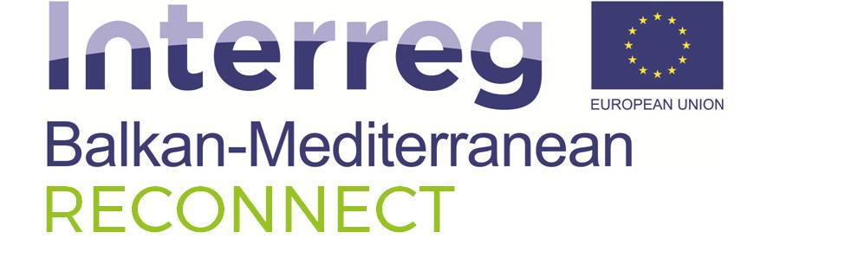

PRESS CONFERENCE

Heraklion, 13/11/2017

The Kick off meeting of the project RECONNECT: «Regional cooperation for the transnational ecosystem sustainable development» was organised by the Hellenic Centre for Marine Research (HCMR) at 8-9/11/2017 in Heraklion, Crete. The project RECONNECT aims to develop strategies for the sustainable management of Marine Protected Areas and Natura 2000 areas in the Balkan and Mediterranean regions.

The project was submitted and approved under the first call for project proposals of the INTERREG Balkan - Mediterranean 2014-2020 Programme, Priority Axis 2: Environment - Investment Priority 6c: Conserving, protecting, promoting and developing natural and cultural heritage. The total budget of the project is 1.2 million Euros including co-funding by the European Union (ERDF, European Regional Development Fund) and national funding resources by the participating countries.

The main objective of the project is the implementation of field research in order to collect important information on the characteristics of different habitats and the essential marine biodiversity parameters of the study areas. In addition, useful tools will be created for supporting Management Authorities during decision making processes (e.g. monitoring protocols, socio-economic management models, etc). These tools will be offered to the Management Authorities of the Marine Protected Areas in order to contribute to the more effective management of such areas and to the confrontation of environmental threats.

The total duration of the project is 2 years and 7 partners from 4 Balkan and Mediterranean countries are participating:

Greece:

- Hellenic Centre for Marine Research (HCMR)
- Management Agency of Karpathos and Saria
- International Centre for Research on the Environment and the Economy (ICRE8)

Cyprus:

- Department of Fisheries and Marine Research, Ministry of Agriculture, Rural Development and Environment
- Department of Biological Sciences, University of Cyprus

Bulgaria:

- Institute of Biodiversity and Ecosystem Research

Albania:

- Faculty of Natural Sciences, University of Tirana

